Viewing Frustum

📘 Definition
# Source: AI Source: Provided by: [Data Path: Persons Table -> ID Column: 1, Name_En Column: Motasem Essam] -> From: [ChatGPT] on [5/2/2026]
A viewing frustum is the 3D region of space that a camera can see in computer graphics. Only objects inside this region are visible in the final image; everything outside it is not rendered.
It looks like a truncated pyramid (a cut-off pyramid).

📐 Shape of the viewing frustum
# Source: AI Source: Provided by: [Data Path: Persons Table -> ID Column: 1, Name_En Column: Motasem Essam] -> From: [ChatGPT] on [5/2/2026]
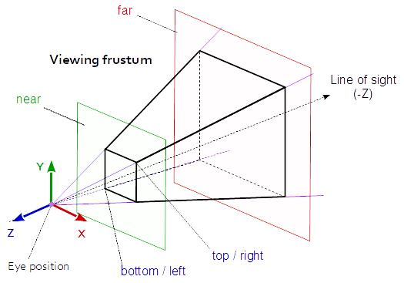
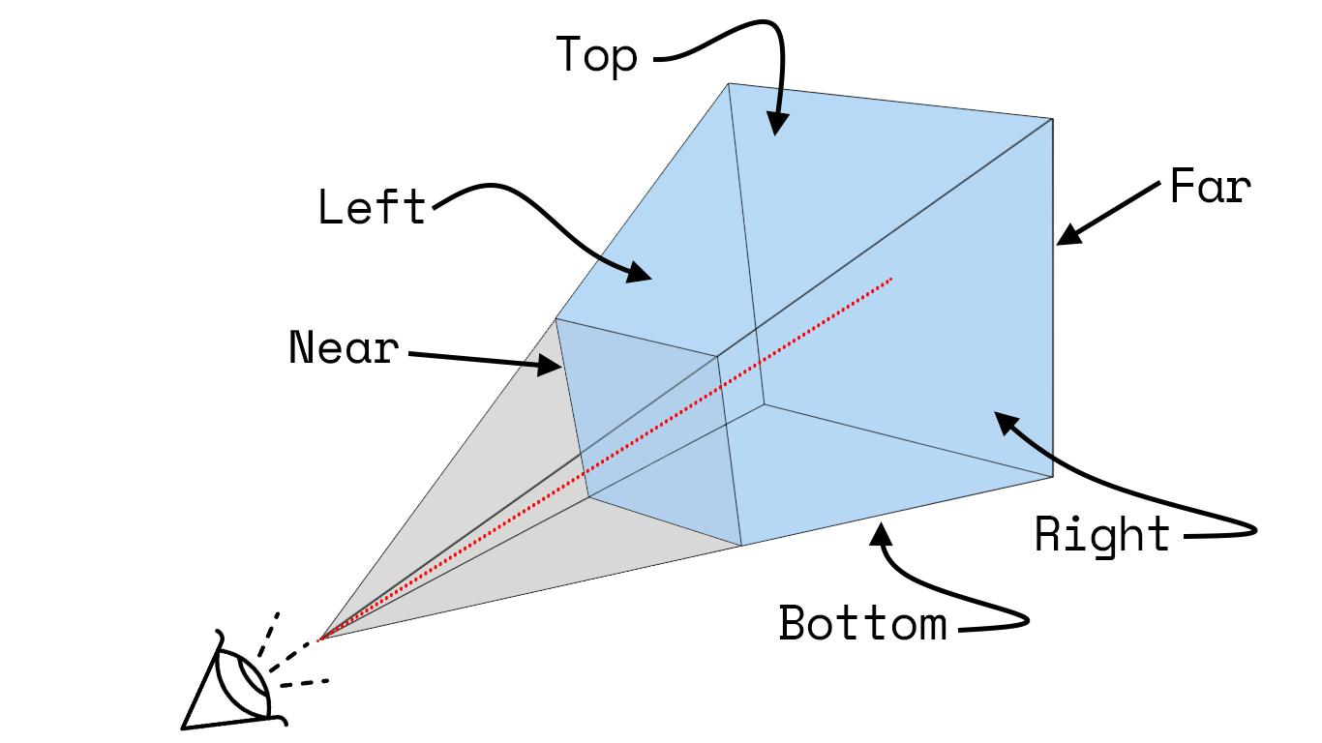
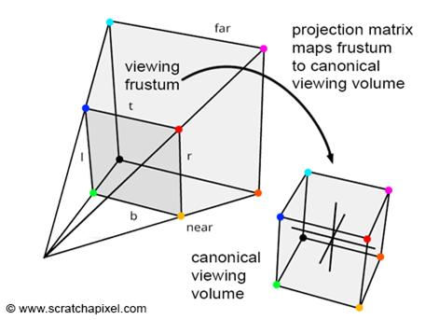
The frustum is defined by:
- 📍 Camera position (apex of pyramid)
- 📏 Near plane → closest visible boundary
- 📏 Far plane → farthest visible boundary
- 🔭 Field of view (FOV) → how wide the view is

🧠 Simple example
# Source: AI Source: Provided by: [Data Path: Persons Table -> ID Column: 1, Name_En Column: Motasem Essam] -> From: [ChatGPT] on [5/2/2026]
Think of:
- 📷 Looking through a camera lens or binoculars
- You can only see what is inside the frame
- Everything outside the frame is invisible
That visible area is the viewing frustum.

🎮 Why it is important in computer graphics
# Source: AI Source: Provided by: [Data Path: Persons Table -> ID Column: 1, Name_En Column: Motasem Essam] -> From: [ChatGPT] on [5/2/2026]
The viewing frustum is used to:
- 🎮 Decide what objects are visible in games
- 🚀 Improve performance using frustum culling (hide unseen objects)
- 🧑‍💻 Control camera rendering in 3D software
- 🎬 Define what appears in the final image or scene

⚙️ Key features
# Source: AI Source: Provided by: [Data Path: Persons Table -> ID Column: 1, Name_En Column: Motasem Essam] -> From: [ChatGPT] on [5/2/2026]
- 📐 3D pyramid-like shape (truncated)
- 📷 Based on camera position and direction
- 🚫 Objects outside are not rendered
- 🎯 Helps optimize graphics performance

🚀 In short:
# Source: AI Source: Provided by: [Data Path: Persons Table -> ID Column: 1, Name_En Column: Motasem Essam] -> From: [ChatGPT] on [5/2/2026]
Viewing Frustum = the 3D visible area of a camera in which objects are seen and rendered in computer graphics.

